[TRIP TITLE – “Trip Type_Country_Middle or High School”]
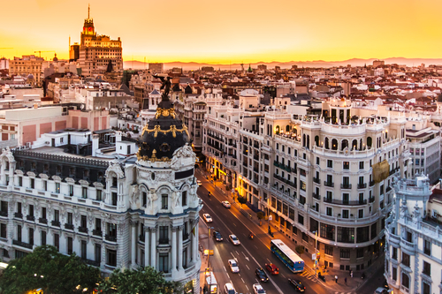

[Provide a landscape/cityscape image corresponding to destination, ideally without travelers pictured.]

[Write a short paragraph describing the trip, mentioning trip highlights, trip type (language immersion, service learning, etc.) and basic tour structure. Do not include name or logo of educational travel vendor anywhere on this packing list.]

Country Information
[Write a short paragraph describing the destination, including climate, topography, and weather at the time of year visiting. Provide context for towns/cities visited in-country. Provide information about relevant cultural norms, especially as pertaining to attire.]

Packing Suggestions
[Provide a bulleted list of suggested items that students do and do not pack, based on cultural norms, tour length, itinerary and activities, and destination climate/weather at time of visit.]

