Grade 5> Mathematics> Activity 1>
Estimating Whole Numbers and Decimals

What you will Need:
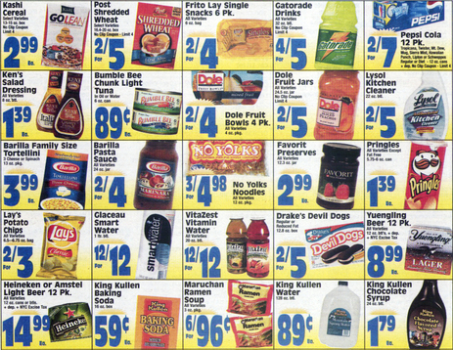
A piece of paper
A Grocery Circular
Pencil

Activity:
Helpful Hint:
Anything less than 5 rounds down (2.49 rounds to 2)
(2.51 rounds to 3)

Create a grocery shopping list with your child
Find the item prices in the grocery circular ads
Ask your child to estimate to the nearest dollar
how much each item will cost.
When you finish the list, have them estimate the total.

This can be a weekly routine with your child!

