[TRIP TITLE – “Trip Type_Country_Middle or High School”]
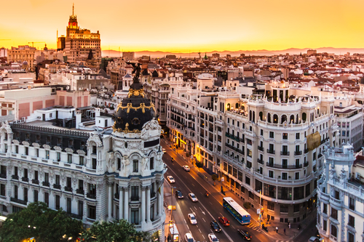

[Provide a landscape/cityscape image corresponding to destination, ideally without travelers pictured.]

[Write a short paragraph describing the trip, mentioning trip highlights, trip type (language immersion, service learning, etc.) and basic tour structure. Do not include name or logo of educational travel vendor.]

Daily Itinerary
Day 1 | Departure  - Note method of transport between airport and accommodations for the night
Day 2 | Overnight Location  - Hourly schedule of activities for the day, including visits to major landmarks and activities.  - Meal times and locations (i.e. hotel, local restaurant) for breakfast, lunch, and dinner  - Note ground transportation and method, if applicable
Day 3 | Overnight Location  - Hourly schedule of activities for the day, including visits to major landmarks and activities.  - Meal times and locations (i.e. hotel, local restaurant) for breakfast, lunch, and dinner  - Note ground transportation and method, if applicable
Day 4 | Overnight Location  - Hourly schedule of activities for the day, including visits to major landmarks and activities.  - Meal times and locations (i.e. hotel, local restaurant) for breakfast, lunch, and dinner  - Note ground transportation and method, if applicable
Day 5 | Overnight Location  - Hourly schedule of activities for the day, including visits to major landmarks and activities.  - Meal times and locations (i.e. hotel, local restaurant) for breakfast, lunch, and dinner  - Note ground transportation and method, if applicable
Day 6 | Overnight Location  - Hourly schedule of activities for the day, including visits to major landmarks and activities.  - Meal times and locations (i.e. hotel, local restaurant) for breakfast, lunch, and dinner  - Note ground transportation and method, if applicable
Day 7 | Overnight Location  - Hourly schedule of activities for the day, including visits to major landmarks and activities.  - Meal times and locations (i.e. hotel, local restaurant) for breakfast, lunch, and dinner  - Note ground transportation and method, if applicable
Day 8 | Overnight Location  - Hourly schedule of activities for the day, including visits to major landmarks and activities.  - Meal times and locations (i.e. hotel, local restaurant) for breakfast, lunch, and dinner  - Note ground transportation and method, if applicable
Day 9 | Departure  - Note method of transport to airport

