Kindergarten> Mathematics> Activity 4

**What you will need:**

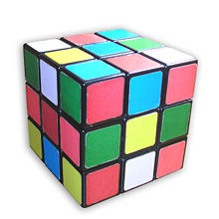 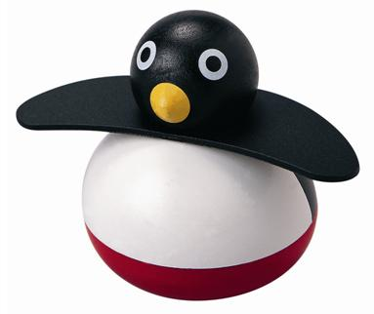 

15-20 toys or objects of different sizes in your home

Wh**at you will do:**

Have your child line up the toys from largest to smallest, then have them count the number of toys.

Mix up the toys and add in different toys and take previous toys from the pile.

Again, have your child line up the toys from largest to smallest, then have them count the number of toys.

**What they are learning:**