December 18, 2019
Dear DCPS Community —
Over the past two weeks, we have engaged numerous stakeholders including staff, students, families and community members around the proposal to close Washington Metropolitan High School (Wash Met) at the end of this school year. These conversations reflected your deep care and concern for the success of Wash Met students, and we thank those who took time to call, write, or share their thoughts in person. Through our engagement, we have heard loudly and clearly that students must be at the center of this process.
We heard that students need access to resources and opportunities that put them on a path to college and career. The Wash Met school community values a supportive learning environment that includes meaningful student-staff relationships, engaging programming in and out of the classroom, and wrap-around support structures for students.
We heard that the Wash Met building is not conducive to high school programming. We heard that students are seeking a modernized learning environment that provides common spaces to learn and engage in academic, athletic, and enrichment programming.
We heard that personalized student support is a priority. We recognize the disruption this proposal has on the Wash Met community and should it move forward, we are committed to 1:1 transition conversations with students and families.
You can also review full notes from Wash Met community forums held on December 9 and 12 on the DCPS Strategic School Planning blog. We will utilize the blog to provide additional updates as the decision-making process moves along. Here is an overview of the process to date and next steps:
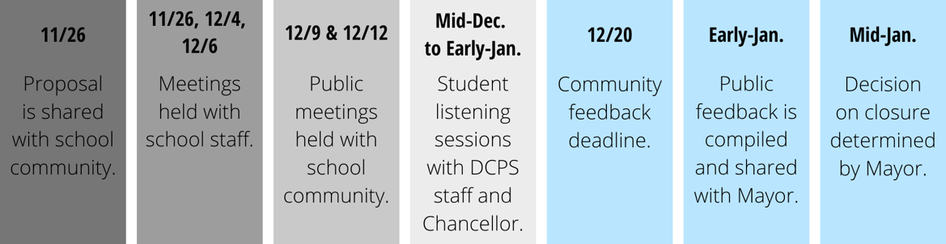
As a reminder, we are still accepting public feedback on the proposal through this Friday, December 20. Please share your thoughts via email to DCPS.Planning@k12.dc.gov. In response to community feedback, we have also established a voicemail box at 202-478-9289.
Thank you again for your active engagement in this process. Your partnership is critical as we work to improve student success. Please visit the DCPS School Planning blog to explore the community resources available around Wash Met, including an updated FAQ, community meeting notes, and letters to school families.
Sincerely,
Melissa Kim
Deputy Chancellor

